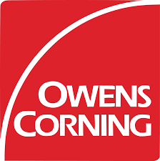
Owens Corning Virtual IRE Booth at a Glance
Owens Corning Spotlights Shingle Performance, Technologies & Contractor Education
As the inaugural Virtual International Roofing Expo approaches, Owens Corning is shining the spotlight on tools and resources that deliver extreme performance, help roofing contractors navigate a socially distanced environment, and deliver education on demand. Contractors can check out the following Owens Corning resources presented virtually at IRE, March 2-4, 2021.
- Performance and Beauty Converge
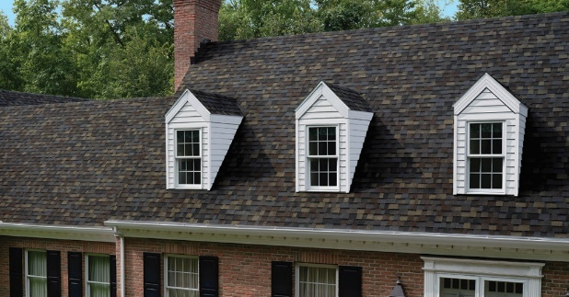
Compared to competitive shingles, Owens Corning Oakridge® and Duration® Shingles outperform where it matters most – in the nailing zone. Oakridge® shingles are equipped with a full double layer in the nail zone. Head-to-head tests show the outstanding performance of a double-layer nail zone, as Oakridge shingles offer up to 2X better nail pull-through resistance, up to 7X better nail blow-through resistance, and up to 1.5X better delamination resistance versus the top two competitors.* Bringing performance to an even higher level, Duration® Series features a triple layer of reinforcement in the nailing zone that delivers up to 2.5X better nail pull-through resistance, up to 9X better nail blow-through resistance, and up to 2X better delamination resistance compared versus the top two competitors.* What do contractors have to say when it comes to performance in the critical nailing zone? Nine out of 10 contractors agree that shingles are more securely fastened when nailed through a common bond in the nailing zone.
Proper shingle installation is essential to performance. Duration® Series shingles come standard with patented SureNail® technology, featuring a wide, highly visible engineered fabric strip in the nailing area for a consistent, quality installation. The unique product design provides outstanding gripping power. Nine out of 10 contractors agree that SureNail® technology gives the most visible nailing line.
New in 2021, an expanded array of premium color blends has been added to the Duration FLEX® line. Black Sable, Sand Dune, Storm Cloud, and Summer Harvest are the four newest shingle colors to join the Duration FLEX® family, fusing the power of color with high performance. And speaking of color, the 2021 Owens Corning Shingle Color of the Year, Aged Copper, will be on display in the IRE virtual booth. As part of the TruDefinition® Duration® Designer Line, the shade brings a sense of calm and serenity at a time when extreme events are making homes a sanctuary.
TruDefinition® Duration FLEX® shingles offer more flexibility than standard shingles for enhanced durability and performance in all environmental conditions, including storms and cold weather installation. They’re the only modified polymer shingle that comes with the advanced performance of patented SureNail® Technology for incredible strength and wind resistance. Like other Duration shingles, Duration FLEX® shingles have a limited lifetime warranty and offer a 130-MPH wind resistance limited warranty.
During Virtual IRE, Owens Corning is showcasing the Total Protection Roofing System®.^ One System. One Brand. Total Protection™. The Owens Corning® Total Protection Roofing System® helps a roof perform in three critical areas: SEAL, DEFEND, and BREATHE. The seal provides powerful two-part protection to help keep moisture away from the roof deck. As the Total Protection Roofing System® defends, three kinds of shingles work together for specialized protection on each part of the roof. And finally, proper ventilation helps a home breathe by creating a balanced flow where warm, humid air is continually replaced by cool, dry air.
As contractors continue to make the switch to synthetic, Owens Corning® ProArmor® Synthetic Roof Underlayment with Fusion Back Coating Technology™ offers a new look and enhanced features, including increased UV exposure up to 90 days and approval for use under metal roofing.
- Technology Tools Contractors Can Use
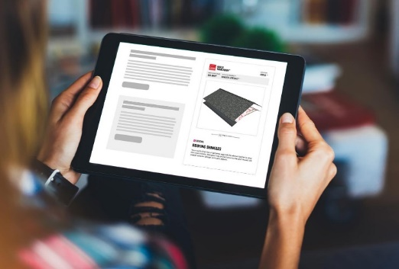
To support social distancing measures and keep contractors and their customers safe, Owens Corning offers a suite of technological tools that support every step of the selling process.
Launched in 2019, the ProSell™ app provides a seamless process for walking customers through each step of a virtual “in-home” presentation. The seven sales funnel steps are consolidated into one easy-to-use resource that allows customers to select products, sign contracts, and process payments during a single appointment.
The Build Your Roof™ online tool provides customer education and engagement, as it empowers customers to understand how each layer and component of the Total Protection Roofing System® supports performance. The widget explains how the roofing system seal, defend, and breathe functions work together to create a waterproof barrier, defend against nature’s elements, and help air flow through the attic to manage temperature and moisture. This systematic approach can help guard against problems such as ice damming, roof deterioration, and mold.
Owens Corning has curated a collection of customizable web widgets that contractors can access to educate and inspire homeowners. Instructions for uploading the widgets are available at www.owenscorning.com/roofingwidgets.com. Widgets are available for Shingles, Build Your RoofTM, Total Protection Roofing System®, Design & Inspire Style Boards, DesignEyeQ®, and the Warranty widget which makes it fast and easy to compare different warranties.

- Owens Corning University Engagement Hub, Power Hours and Virtual Business Day
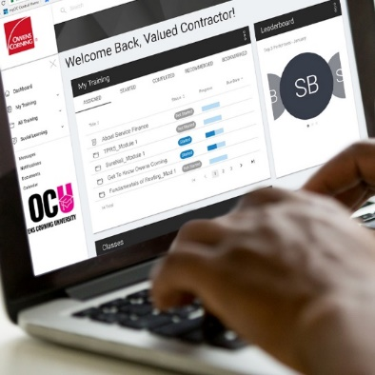
As an online educational portal available to members of the Owens Corning Roofing Contractor Network, Owens Corning University (OCU) is home to a suite of educational resources. Under the OCU “learning umbrella” are a portfolio of technologies and tools to support contractors.
The new Owens Corning University (OCU) Engagement Hub provides easy access to industry-leading information, online training, and education covering every aspects of a contractor’s business. The hub houses curated resources such as on-demand webinars, installation videos, and training materials, making it easy for contractors to navigate topics, filter by category, and efficiently access resources on demand.
In an era of remote learning, Owens Corning is bringing practical and timely online education to the roofing community with Power Hour on-demand learning. Tech talk, branding, and business management are among the topics covered in Power Hours.
As the spring home improvement season gets into full swing, a Virtual Business Building Day on Wednesday, April 7, will convene leading resources to help contractors take their business to the next level. The virtual Business Building Day equips contractors with new tools and services engineered to drive growth. Resources help contractors evaluate their business, target growth goals, implement strategies to achieve key performance metrics such as higher conversions and revenues, help lower costs, and identify strategies to help convert more leads into closed business. The Virtual Building Day provides contractors with a one-stop shop for accessing experts representing solutions and technologies across the roofing industry.
© 2021. Owens Corning. All rights reserved.
*Owens Corning testing against competing shingles with a wide single-layer nailing zone when following the manufacturer’s installation instructions and nailed through the middle of the allowable nail zone.

** Owens Corning Contractor Research, August 2019. SureNail® Technology is not a guarantee of performance in all weather conditions.

SureNail® Technology is available only on Owens Corning Duration® Series Shingles. For patent information, please visit www.owenscorning.com/patents.

^ Excludes non-Owens Corning® roofing products such as flashing, fasteners, pipe boots, and wood decking.
†† See actual warranty for complete details, limitations, and requirements.

